|  |  |
| --- | --- |
| **Course Code: CSL601** | **Course Name: SE LAB** |
| **Class : TE-CO** | **Batch : 3** |
| **Roll no : 18CO63** | **Name : SHAIKH TAUSEEF MUSHTAQUE ALI** |

**Experiment : 05**

**Aim : Identify scenarios & develop UML Use case and Class Diagram for the project.**

**Output :**

**USE CASE MODEL:**

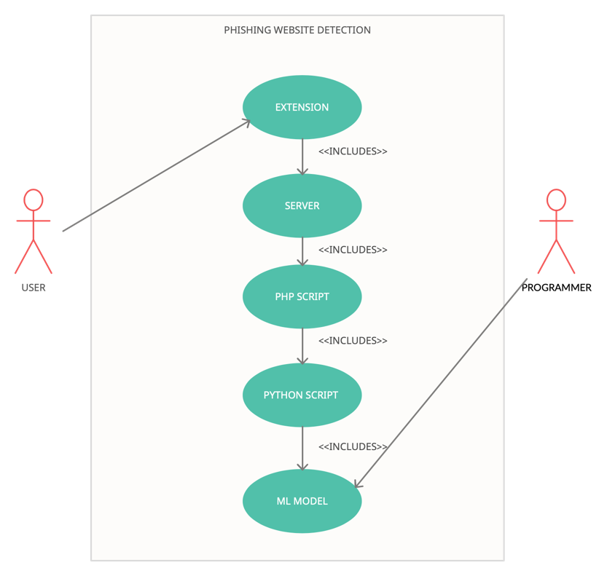

**CLASS DIAGRAM:**

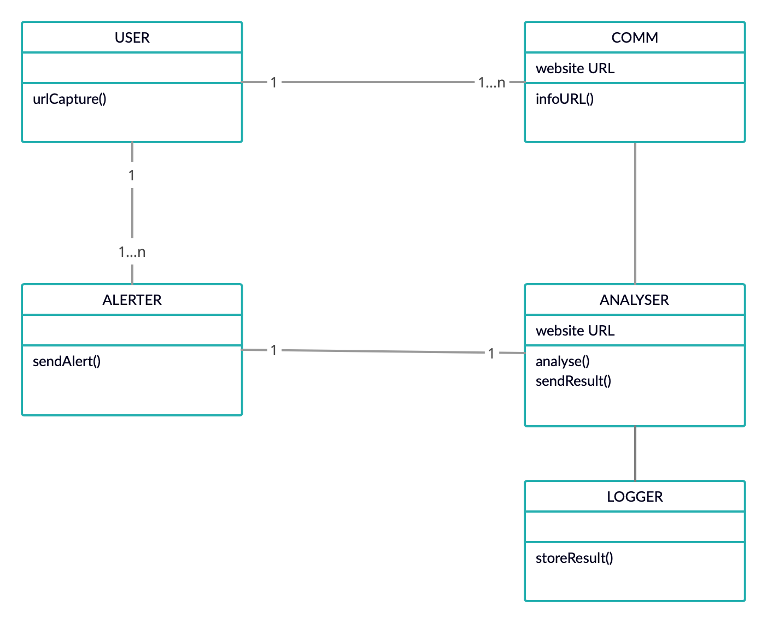

**Reference:**

[**https://online.visual-paradigm.com/**](https://online.visual-paradigm.com/)

[**https://www.uml-diagrams.org/use-case-diagrams.html**](https://www.uml-diagrams.org/use-case-diagrams.html)

[**https://www.uml-diagrams.org/class-diagrams-overview.html**](https://www.uml-diagrams.org/class-diagrams-overview.html)

[**https://www.draw.io/**](https://www.draw.io/)

[**https://creately.com/**](https://creately.com/)

**Dia**

**Conclusion:**

|  |
| --- |
| With the help of this experiment, we get to know about how to develop a use case diagram and class diagram |
| Of our specific project topic. |